LOWER ELKHORN NRD
TREE PICKUP DATES
For your trees and/or mats
Lower Elkhorn NRD – 402-371-7313

Friday April 18, 2025 – 8:30 AM – 12:00 PM
Thursday April 24, 2025 – 9:00 AM – 6:00 PM
Friday April 25, 2025 – 8:30 AM – 2:00 PM

TREE DISTRIBUTION CENTER

MASKENTHINE LAKE

From Highway 275 and Highway 57 Junction
(north of Stanton) One mile west on 275 to Ridge Road,
or
Approximately 8 miles east of Norfolk on Highway 275 to Ridge Road,
then
South 2 miles, then ½ mile west and you will see a big
tan/green building on the right

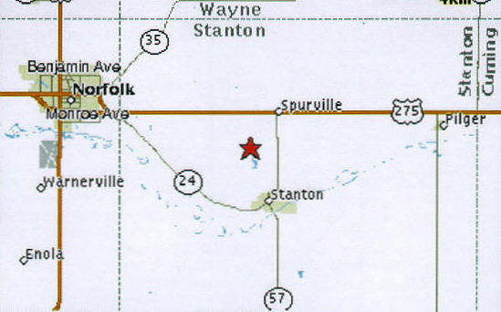

Any orders not picked up on specified dates or without other arrangements made will be forfeited and no refund issued.

